1. Problem Statement
Represent multiple classrooms and seating positions as nested lists; allocate students, detect assignments, and calculate vacant capacity.
2. Objectives
- Use nested lists (a list inside a list) to represent a 2D seating grid.
- Count occupied and vacant seats using basic loops.
3. Assumptions
- Let 0 represent an empty seat and 1 represent an occupied seat.
4. Algorithm
- Start.
- Define a nested list representing the classroom grid.
- Use nested for loops to iterate through rows and columns.
- Count how many 0s (vacant) and 1s (occupied) are present.
- Display total, occupied, and vacant seat counts.
- Stop.
5.Flowchart
[Start]
--> [Define Classroom 2D Grid of 0s (Vacant) and 1s (Occupied)]
--> [Initialize total, occupied, and vacant counters to 0]
--> [Outer Loop: Iterate through each row]
--> [Inner Loop: Iterate through each seat in row]
--> [Check seat value == 1?]
├── Yes --> [Increment occupied counter]
└── No --> [Increment vacant counter]
--> [Print Occupied and Vacant Seat Totals]
--> [Stop]
6. Pseudocode
START
// Classroom seating grid (0 = Empty, 1 = Occupied)
classroom = [
[1, 0, 1],
[0, 0, 1],
[1, 1, 0]
]

occupied_count = 0
vacant_count = 0

FOR each row IN classroom DO
FOR each seat IN row DO
IF seat == 1 THEN
occupied_count = occupied_count + 1
ELSE
vacant_count = vacant_count + 1
ENDIF
ENDFOR
ENDFOR

PRINT "Total Occupied Seats:", occupied_count
PRINT "Total Vacant Seats:", vacant_count
STOP
7. Python Source Code
print("=== Classroom Occupancy Analysis ===")

classroom_grid = [
[1, 0, 1, 1],
[0, 0, 1, 0],
[1, 1, 1, 0]
]

total_seats = 0
occupied_seats = 0
vacant_seats = 0

for row in classroom_grid:
for seat in row:
total_seats = total_seats + 1
if seat == 1:
occupied_seats = occupied_seats + 1
else:
vacant_seats = vacant_seats + 1

print("\n--- Occupancy Report ---")
print("Total Seats in Room :", total_seats)
print("Occupied Seats :", occupied_seats)
print("Vacant Seats :", vacant_seats)
8. Test Cases & Output Log
- Test Case: Grid with 12 total seats (7 occupied, 5 vacant).
- Log:
=== Classroom Occupancy Analysis ===

--- Occupancy Report ---
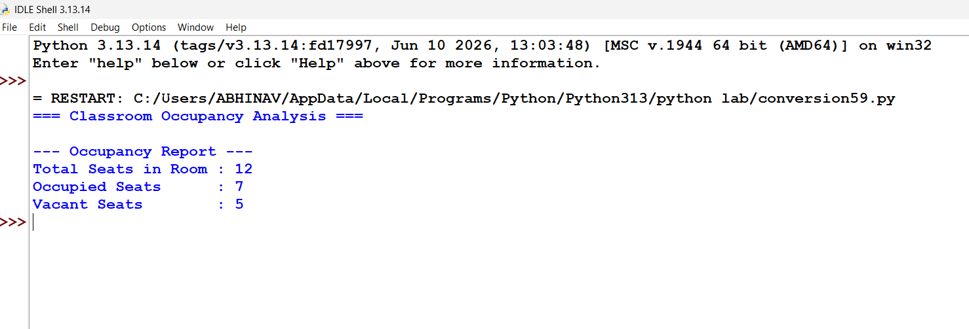
Conclusion: Successfully modeled a 2D seating grid using nested lists and loops to accurately track occupied versus vacant capacities within a classroom setting.

